VAPT 4th Report
1 – Advanced Exploitation
Target: 192.168.0.142 (Mr.Robot VM)
Tools: Metasploit

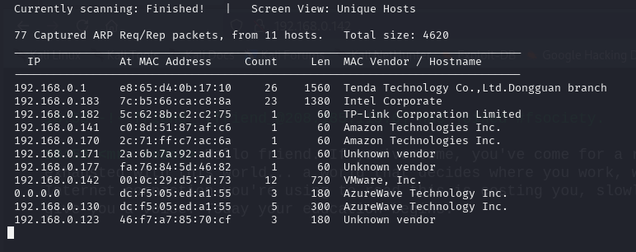
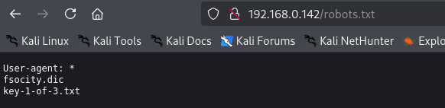
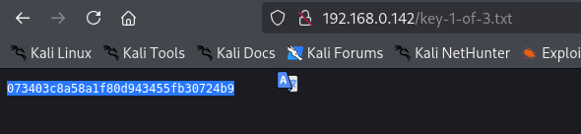
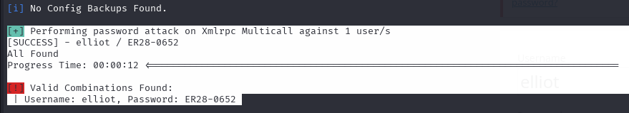
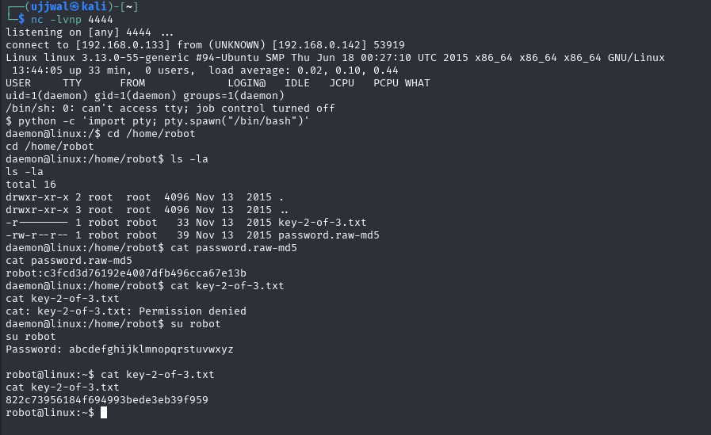
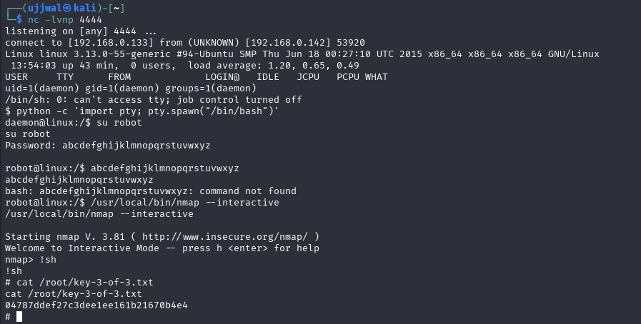

2 – API Security Testing Lab
Description:
DVWA API testing
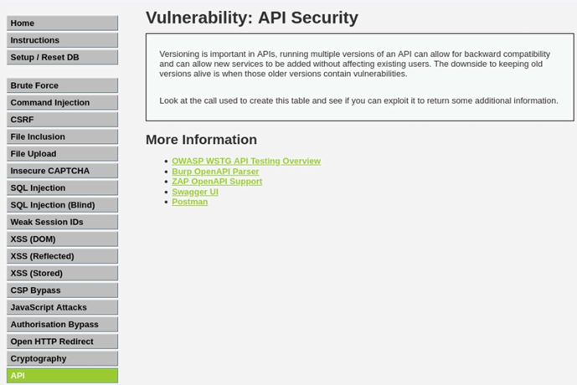

3 – Privilege Escalation and Persistence Lab
Target: 192.168.0.142 (Mr.Robot VM)
Tools: metasploit

5– Mobile Application Testing

Vulnerability | Severity
Cleartext Traffic Enabled | High
Trusts User-Installed Certificates | High
App Supports Outdated Android Version | High
Insecure External Storage Access | Warning
allowBackup Enabled | Warning
Exported Activity - CurrencyRates | Warning
Exported Activity - SendMoney | Warning
Exported Activity - ViewBalance | Warning
Exported Activity - Biometric Handler | Warning
Logs Sensitive Information | Info
Hardcoded API Keys (Firebase/Google) | Info

2 – API Security Testing Lab
DVWA API testing
